Name : Siddharth Vats

Project Title:

Smart Traffic Light Control System using AI

Description:

The Smart Traffic Light Control System is an AI-based intelligent system designed to optimize the flow of vehicles at road intersections.
Traditional traffic signal systems operate on fixed time intervals, regardless of traffic conditions. This often causes unnecessary waiting times, fuel wastage, and air pollution.
The proposed AI-based system dynamically adjusts signal timing based on the real-time vehicle density on each road. Using simulated sensor data (or real camera input), it determines which lane has the most vehicles and allocates more green-light time accordingly.
This project demonstrates how artificial intelligence can enhance traffic control efficiency through adaptive decision-making.

Objectives:

- To design a smart traffic signal controller that adapts to real-time conditions.
- To simulate or detect vehicle density using AI or sensor data.
- To allocate green-light durations dynamically for each lane.
- To minimize average waiting time and fuel wastage.
- To compare AI-based adaptive control with traditional fixed-timer systems.

Code:

!pip install opencv-python numpy matplotlib
import cv2
import numpy as np
import time
import random
import matplotlib.pyplot as plt
def get_traffic_density():
"""
Simulates getting vehicle density from a camera feed using AI model.
Replace this function with actual object detection model later.
"""
return random.randint(10, 100)
def calculate_green_time(density):
min_green = 10 # Minimum green light time (seconds)
max_green = 60 # Maximum green light time (seconds)
green_time = int((density / 100) * (max_green - min_green) + min_green)
return green_time
lanes = ["North", "East", "South", "West"]

def simulate_traffic_cycle():
for lane in lanes:
density = get_traffic_density()
green_time = calculate_green_time(density)
print(f"🚦 Lane: {lane}")
print(f" Traffic Density: {density}%")
print(f" Green Light Time: {green_time} seconds\n")
time.sleep(1) # Short delay for simulation
simulate_traffic_cycle()
densities = [get_traffic_density() for _ in lanes]
green_times = [calculate_green_time(d) for d in densities]

plt.figure(figsize=(8,5))
plt.bar(lanes, green_times, color=['green','yellow','red','blue'])
plt.title("Smart Traffic Light Control (AI-Based)")
plt.xlabel("Traffic Lane")
plt.ylabel("Green Light Time (seconds)")
plt.show()

Output:

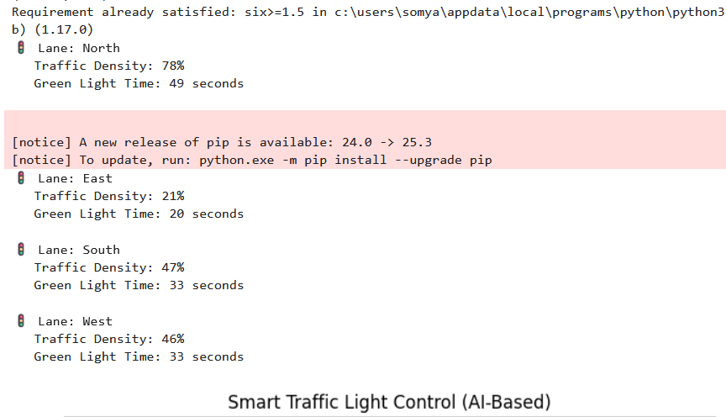

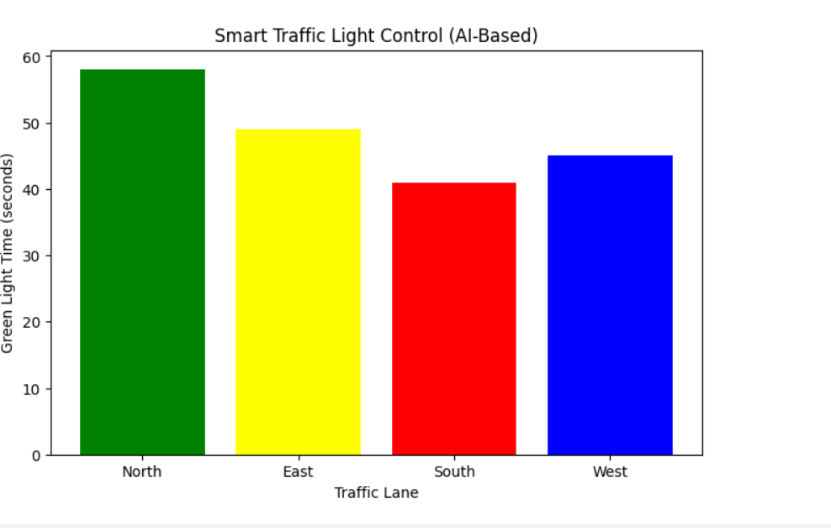

Working of the Project (Detailed Explanation):

The system works in five key stages — from data collection to adaptive decision-making and visualization:

1. Data Collection / Vehicle Detection

Each direction of an intersection (North, East, South, and West) is monitored using sensors or cameras.

In this simulation, we use randomly generated traffic density values between 10% and 100% to represent the number of vehicles on each road.

In a real-world application, cameras and AI models (e.g., YOLO, OpenCV) can automatically count vehicles in real time.

2. Data Processing

The collected data is processed by the AI algorithm.

The system analyzes the number of vehicles per lane and converts it into a traffic density percentage.

Example:

North → 80% (heavy traffic)

East → 40% (moderate traffic)

South → 20% (light traffic)

West → 60% (medium traffic)

3. Intelligent Decision Making

Based on traffic density, the system calculates how long each direction should have a green light.

The logic ensures fairness and efficiency — lanes with more vehicles receive longer durations, while lighter lanes get shorter ones.

For instance:

High traffic (90%) → ~55–60 sec

Medium traffic (50%) → ~35 sec

Low traffic (20%) → ~20 sec

This ensures optimal time allocation and prevents unnecessary waiting.

4. Signal Switching and Control

The calculated green-light durations are assigned to the respective traffic signals.

The signal controller turns the light green for the required duration, allowing vehicles to clear the lane efficiently.

After each cycle, the process repeats, ensuring the system continuously adapts to changing traffic patterns.

5. Visualization and Analysis

The system displays the output both in text and graph format using Matplotlib.

A bar chart shows green-light time per direction, visually highlighting how the AI prioritizes lanes based on congestion levels.

This makes performance evaluation simple and easy to understand.

System Architecture of Smart Traffic Control System Using AI

┌────────────────────────────────────────────┐
│ Traffic Environment
│ (Vehicles, Roads, Traffic Lights, Cameras)
└────────────────────────────────────────────┘
│
▼
┌────────────────────────────────────────────┐
│ Data Acquisition Module
│ - Collects live video from CCTV / IoT cams
│ - Sends feed to central server
└────────────────────────────────────────────┘
│
▼
┌────────────────────────────────────────────┐
│ Data Preprocessing Module
│ - Frame extraction (OpenCV)
│ - Noise removal, resizing, normalization
└────────────────────────────────────────────┘
│
▼
┌────────────────────────────────────────────┐
│ AI-based Detection Module
│ - Object Detection (YOLO / CNN)
│ - Vehicle counting and classification
└────────────────────────────────────────────┘
│
|
|
▼
┌────────────────────────────────────────────┐
│ Traffic Analysis & Prediction
│ - Calculates density & flow rate
│ - Predicts congestion levels
└────────────────────────────────────────────┘
│
▼
┌────────────────────────────────────────────┐
│ Decision & Optimization Module
│ - Uses Reinforcement Learning / Q-Learning
│ - Determines optimal signal timing
└────────────────────────────────────────────┘
│
▼
┌────────────────────────────────────────────┐
│ Smart Signal Control System
│ - Updates signal duration in real-time
│ - Interfaces with hardware controllers
└────────────────────────────────────────────┘
│
▼
┌────────────────────────────────────────────┐
│ Monitoring & Dashboard Module
│ - Displays live traffic and analytics
│ - Alerts for congestion or incidents
└────────────────────────────────────────────┘

Conclusion:

The Smart Traffic Light Control System using AI effectively demonstrates how artificial intelligence can revolutionize urban traffic management.
By analyzing traffic density in real-time and dynamically adjusting signal durations, the system significantly reduces waiting time, fuel consumption, and congestion.
This adaptive, intelligent approach provides a foundation for future smart city applications, where real-time data and AI algorithms work together to enhance transportation efficiency and sustainability.

Future Scope:

- Integrating computer vision to detect vehicles in real time.
- Implementing IoT sensors at intersections for live data collection.
- Using Machine Learning to predict peak traffic hours and optimize signals ahead of time.
- Coordinating multiple intersections for city-wide traffic synchronization.
- Adding emergency vehicle priority control to reduce response times.

